# Lecture 6. C Loop Control Statements

Loop statements allow you to execute a statement, or a group of statements, multiple times. Types of loops in C programming:

* **for** loop
* **while** loop
* **do...while** loop

Jump statements alter the normal execution sequence of a program:

* **continue** – used to skip some statements inside the loop
* **break** – used to terminate the execution of loop and switch-case statements
* **goto** – used to jump from one statement to another within a function

# for Loop

**for** loop is usually used when the number of iterations is known.

Syntax



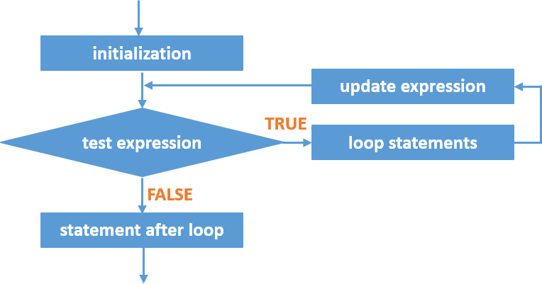

**for** Statement Flowchart

## How it works?

1. The **initialization** is executed first and only once to initialize the loop control variable/counter
2. The **test expression** is evaluated
   * If test expression is found to be false (0), the loop statements will not be executed. Program control jumps to the next statement after the “for” loop.
   * If test expression is found to be true, the statements within the loop will be executed AND

The **update expression** is executed. It will update the loop control variable/counter.

1. Step 2 is repeated until the test expression becomes false or loop is terminated using break statement.

Example:

/* program finds sum of all integer numbers from 1 to n, where n is entered by the user */

#include<stdio.h>

int main(){

int n, counter, sum=0; printf("Enter integer number: "); scanf("%d", &n);

for(counter=1; counter <= n; counter++)

{

sum+= counter;

}

printf("Sum of integer numbers from 1 to %d = %d", n, sum); return(0);

}

## Important to remember

* **for** is a keyword and must be used only in lower case letters
* **for** statement can be an empty statement Example: for(i=1; i<10; i++)

{

}

Result: Variable **i** is incremented

* Semicolon at the end of **for** loop is legal C statement and it will produce the same result as **for** loop with no body.

Example: for(i=1; i<10; i++);

{

statements;

}

Result: Variable **i** is incremented

* Every **for** statement must include initialization, test expression and update expression. They can be empty but must be separated with semicolon (;).

|  |  |
| --- | --- |
| Example | Explanation |
| int i;  for(i=1; i<10; i++)  {  statements;  } | Typical **for** loop |
| int i=1;  for(; i<10; i++)  {  statements;  } | Initialization is not included 🡪  Loop control variable/counter is initiated before the loop |
| int i; for(i=1; i<10;)  {  statements; i++;  } | Update expression is not included 🡪  The update expression is in the loop |
| int i=1; for(; i<10;)  {  statements; i++;  } | Initialization and update expressions are not included 🡪  Loop control variable/counter is initiated before the loop &  The update expression is in the loop |
| for(i=1, j=1; i<5 && j<=10; i++, j++) | There are:   * 2 initializations, separated by comma (,) * Test expression consists of 2 conditions joined together by using logical operator AND (&&) * 2 update expressions, separated by comma (,) |

Nested for Loops

C programming allows using nesting **for** loops – one loop is inside another loop.

Example:

int i,j;

for(i=1; i<5; i++)

{

for(j=1; j<=10; j++)

{

printf(“i=%, j=%d, i+j=%d”, i,j,i+j);

}

printf(“\n”);

}

**References**

* Tan, H.H., and T.B. D’Orazio. *C Programming for Engineering & Computer Science*. USA: WCB McGRaw-Hill. 1999. Print.
* C4learn. "C for loop - types - C Programming." *Learn Programming Language Step By Step*. N.p., 24 Nov. 2013. Web. 05 Mar. 2017. <<http://www.c4learn.com/c-programming/c-for-loop-types/>>.
* Tutorialspoint.com. "For loop in C." *Www.tutorialspoint.com*. N.p., n.d. Web. 05 Mar. 2017.

<<https://www.tutorialspoint.com/cprogramming/c_for_loop.htm>>.